

20th December, 2022

***Dear Colleagues,***

**Invitation to join the NCLT & IBC Committee**

**of PHD Chamber of Commerce and Industry as a Special Invitee**

The Insolvency and Bankruptcy Code (IBC), 2016, has brought forth a new regime for the distressed asset industry in India. It is focussing on time bound resolutions and maximisation of value. In the last five years, our country has witnessed several big-ticket insolvencies, and the IBC underwent a number of changes in response to market forces and industry requirements.

Recognizing the importance of NCLT and Insolvency & Bankruptcy Code, **PHDCCI’s NCLT & IBC Committee** since its inception has created a niche for itself through multiple Flagship Events, Roundtable Discussions, Seminars and Conferences on various important subjects associated to the evolving and existing Insolvency and Bankruptcy Laws in India. These epoch-making programs conducted by the Committee in the past have received an overwhelming response from stakeholders all across.

The Committeehas since beenre-constituted with **Shri GP Madaan** as the Committee Chair; **Shri Abhishek Anand** and **Shri Karan Mehra** are the Co-chairs.

For the present term, the newly re-constituted Committee has opened exclusive membership with the Committee at a nominal membership fee of **INR 3000/-** **(Three Thousand only)** per annum. This membership can also be availed by any officer or an associate in a representative capacity of an organisation.

**Benefits of becoming a member:**

•        Knowledge Platform:  Clarification of major policy issues, redressal of problems of members both at the Central

and State Government levels from Govt. departments, Senior Officials and Advisers

•        Networking Opportunities: Platform to network and liaise with member constituents, Institutions, Central and

State Government Officials, Regulators, Judiciary, Diplomats, etc. that will enable a conducive learning environment for sharing problems and finding prospective solutions

•         Featured Members list on the PHDCCI NCLT & IBC Committee Website

•         Online Membership Community: Stay on top of the latest updates in NLCT & IBC Ecosystem; Share resources and important news

•         Attend Free/Discounted Events: Webinars/Panel discussions/ Seminars/Conference/Workshops

Please click here to access details of activities conducted by NCLT & IBC Committee: [Click here to access](https://drive.google.com/file/d/1w4xneUdIc5uLzUn5CLLJ5VlqDs4s6fg7/view?usp=share_link)

Please click on this link for making payment towards membership fees - <https://rzp.io/l/RfBQCkTi>

Please fill in details as per the following format and send latest by **30th December, 2022**:

Name:  
Designation:  
Organization:  
E-mail:  
Contact no.:

We look forward to your formal consent to becoming a member of the NCLT & IBC Committee to achieve greater heights for PHDCCI and the industry at large. For any query, please reach out to Jitender Rana, Deputy Secretary, PHDCCI at [jitender.rana@phdcci.in](mailto:jitender.rana@phdcci.in) / +91 98733 69696

We look forward to your formal consent to becoming a Member in the NCLT & IBC Committee.

Thanking you in anticipation.

With best regards,

Yours Sincerely

(Karan Mehra)

Co-Chairman

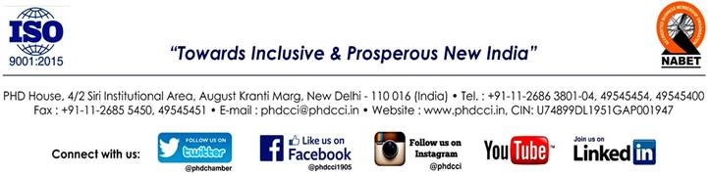NCLT & IBC Committee – PHDCCI